Installation for the application

# download and install visual studio

Go to the <https://visualstudio.microsoft.com/downloads/> website and downloads Visual Studio 2019 Community.

Run de .exe file that you just downloaded.

Click continue and let it download and install.

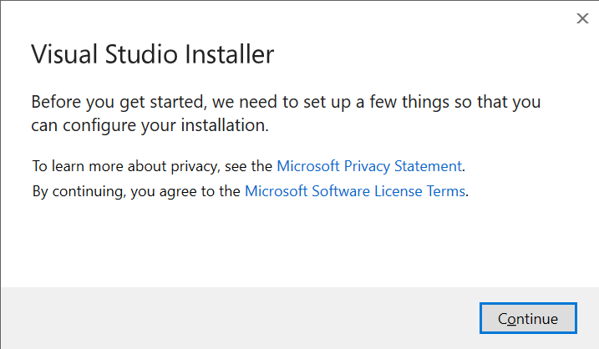

After this a new window will open. Scroll down to the **Desktop & Mobile** section in the **Workloads** tab and tick the **Mobile development with .NET** option.

Select **Install while downloading** in the bottom left corner and click **Install**. This will probably take a while.

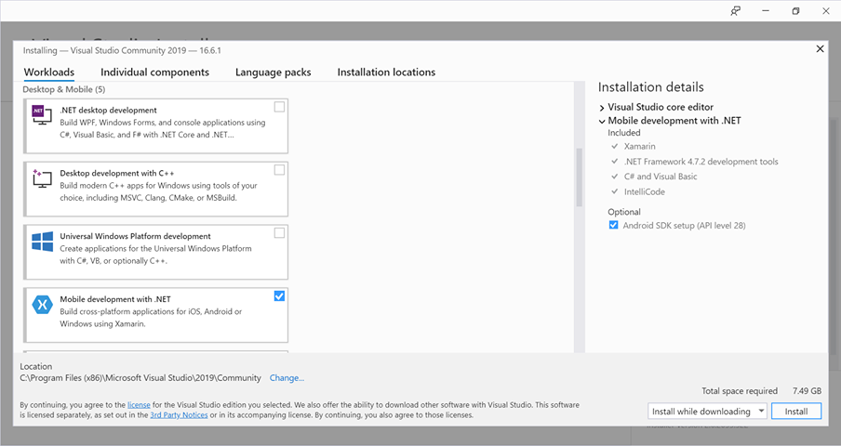

After downloading and installing you’ll have to reboot.

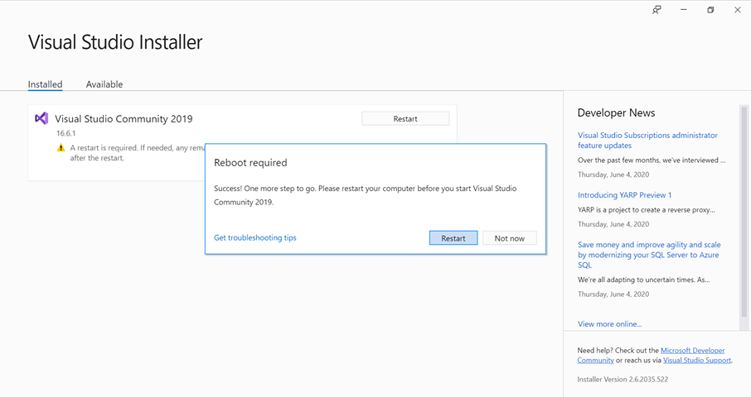

# running the application

Set your phone in to developer mode. You’ll have to look this up on how to do this because this deference from phone.

Connect your phone to the computer with an USB cable. While doing this, you’ll probably get a message on your phone about debugging security. Just give access.

Download the files from this link <https://github.com/GouwyJohannes/HAR_Internship> on GitHub.

Go to the HAR_Internship-master/HARApp folder and double click the HARApp.sln file. This will open the project in Visual Studio.

If you get the pop-up message to sign in, you can click **Not now, maybe later.** on the bottom off the window. 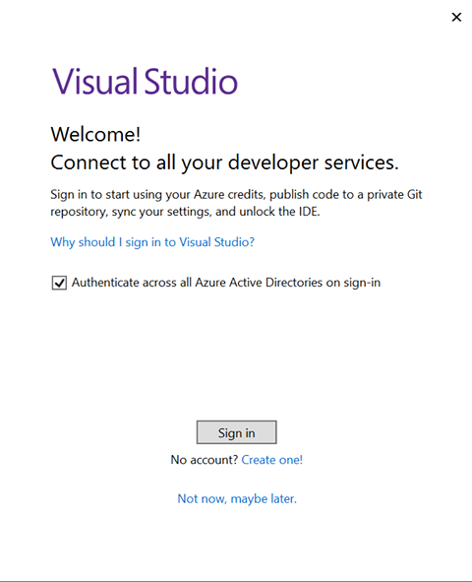

You’ll probably get Security Warnings for the project. You can just ignore these and untick **Ask me for every project in this solution** and click **OK**.

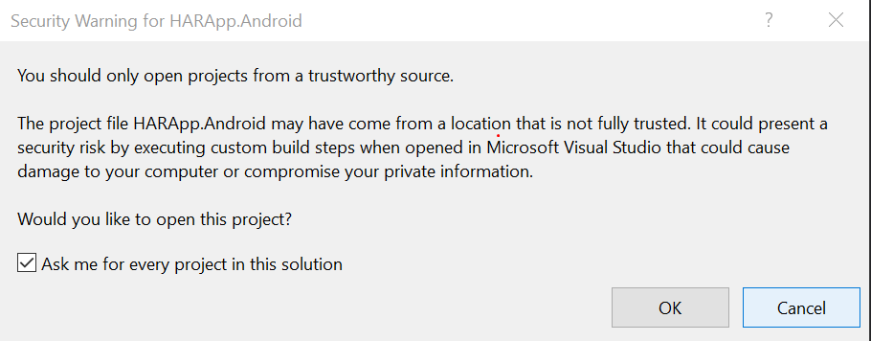

Now the project should be open in Visual Studio. You can see in the top off the window that your phone is connected. By clicking op the play icon, the app will be downloaded on your phone and will open automatically.

